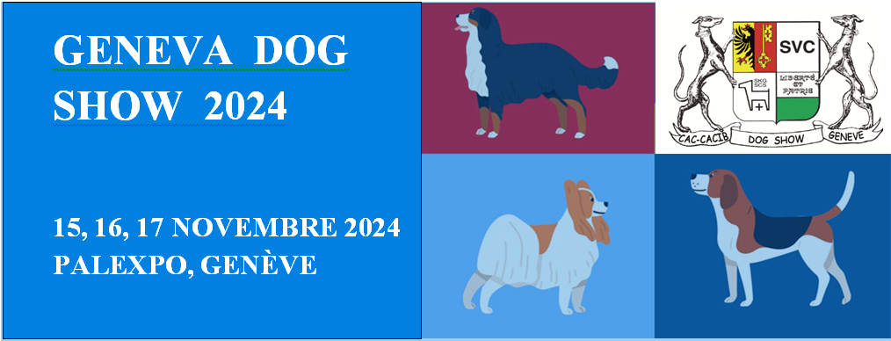

Program

Friday morning November 15, 2024
National dog show for all breeds with SCS CAC award.

Friday afternoon November 15, 2024
International dog show for all breeds with awarding of the CACIB of the FCI
and the CAC of the SCS.

Saturday November 16, 2024
International dog show for all breeds with awarding of the CACIB of the FCI
and the CAC of the SCS.
Qualification for the title “Champion of the Alps”

Sunday November 17, 2024
International dog show for all breeds with awarding of the CACIB of the FCI
and the CAC of the SCS.
Cruft 2025 Qualifier

Organization
Société Vaudoise de Cynologie at the GENEVA PALEXPO exhibition center

Please note: 2 registration deadlines
Until October 17, 2024 1st tax
from October 18, 2024 2nd tax
November 3, 2024 deadline (see prices)

Depending on the number of registrations, the Exhibition Management reserves the right to make modifications.

Information
Email: ecil@bluewin.ch

